Assignment 2

Experiment 1: ICMP Packet Analysis
Aim:
To capture and analyze ICMP packets (ping request and reply).
Procedure:
- Open Wireshark
- Start packet capture
- Run command:
ping google.com
- Stop capture
- Apply filter: icmp
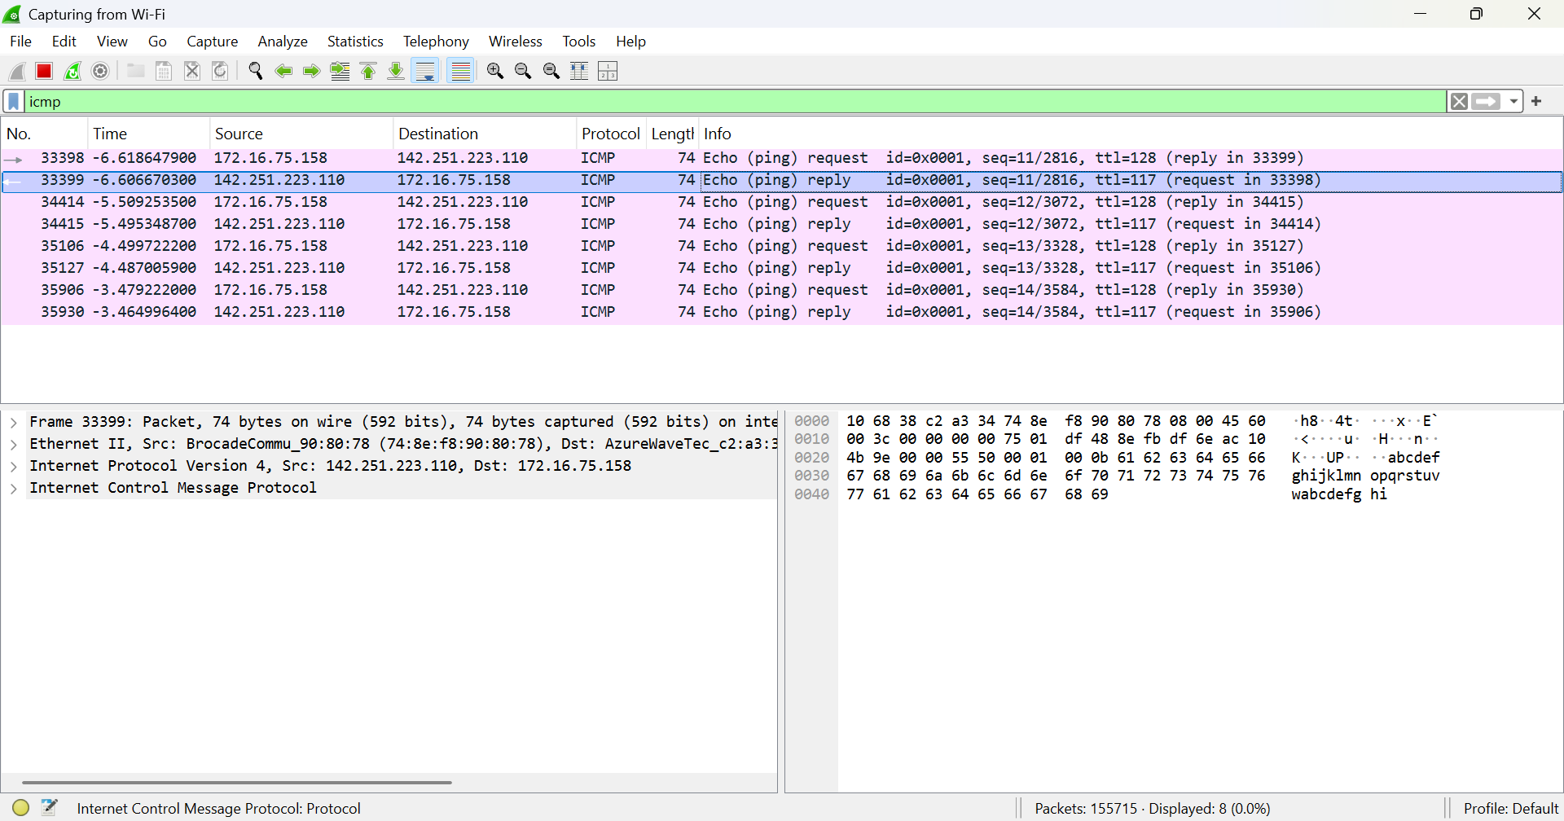
Observation:
- Protocol: ICMP
- Source IP: 192.168.29.1
- Destination IP: 192.168.29.212
- Message: Echo Request
- TTL: 64
Result:
ICMP packets were successfully captured and analyzed.

Experiment 2: TCP Three-Way Handshake
Aim:
To analyze TCP packets and observe the TCP three-way handshake.

Procedure:
- Open Wireshark and start packet capture on the active interface (Wi-Fi).
- Open a web browser and visit any website.
- Stop the capture after a few seconds.
- Apply the display filter: tcp
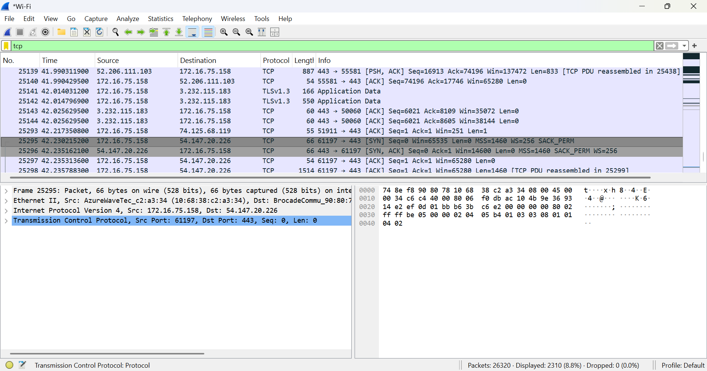
- SYN
  - 172.16.75.158 → 54.147.20.226
  - [SYN]
  - Client is requesting connection
- SYN-ACK
  - 54.147.20.226 → 172.16.75.158
  - [SYN, ACK]
  - Server acknowledges and responds
- ACK
  - 172.16.75.158 → 54.147.20.226
  - [ACK]
  - Client confirms → connection established

Experiment 3: UDP Packet Analysis
Aim:
To capture and analyze UDP packets.
Procedure:
- Open Wireshark and start packet capture on Wi-Fi
- Allow system/network activity to generate traffic
- Stop capture after a few seconds
- Apply the display filter: udp

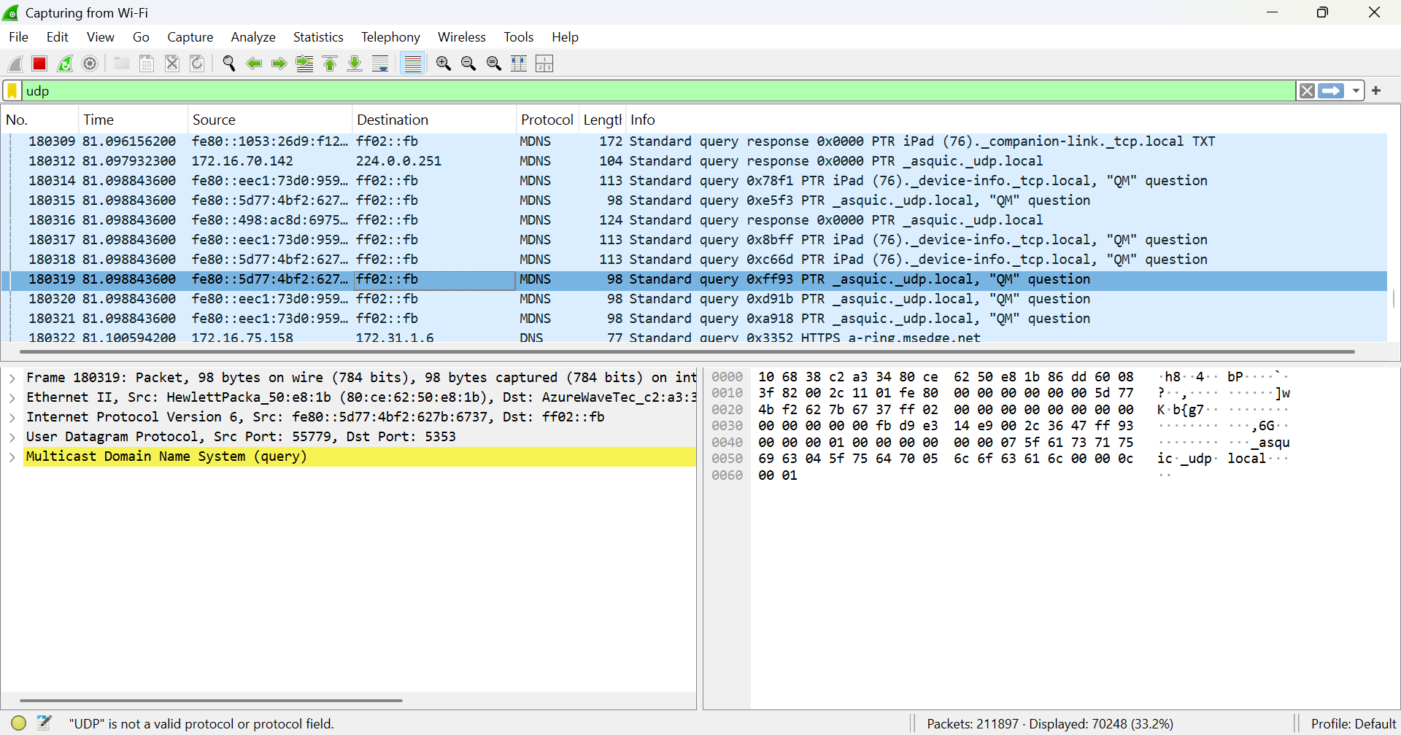
Observation:
From the captured packet:
- Protocol: UDP (mDNS)
- IP Version: IPv6
- Source Address: fe80::5d77:4bf2:627b:6737
- Destination Address: ff02::fb (Multicast address)
- Source Port: 55779
- Destination Port: 5353
- Packet Length: 98 bytes
- Query Type: Standard query (PTR record)
- Service Queried: _asquic._udp.local
Result:
UDP packets were successfully captured.

Experiment 4: DNS Packet Analysis
Aim:
To capture and analyze DNS query and response packets.

Procedure:
- Open Wireshark and start packet capture on Wi-Fi
- Open a web browser and visit any website
- Stop capture after a few seconds
- Apply the display filter: dns
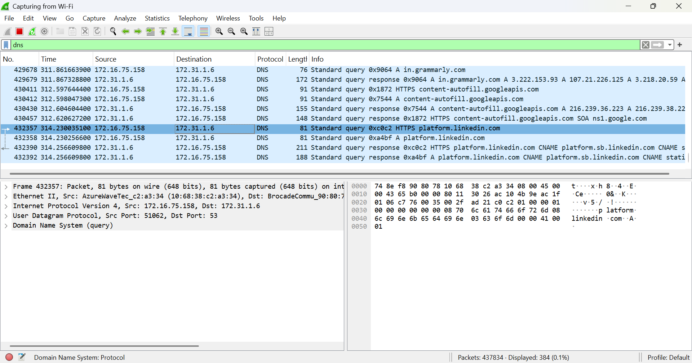
Observation:
From the captured packets:
- Protocol: DNS (over UDP)
- Source IP Address: 172.16.75.158
- Destination IP Address: 172.31.1.6 (DNS server)
- Source Port: 51062
- Destination Port: 53
- Packet Length: 81 bytes
- Domain Queried: platform.linkedin.com
- Query Type: A record (IPv4 address resolution)
- Packet Type: Standard DNS query

Experiment 5: HTTP Packet Analysis
Aim:
To capture and analyze HTTP packets.
Procedure:
- Open Wireshark and start packet capture on Wi-Fi
- Open a web browser and access a non-secure website (HTTP)
- Stop capture after a few seconds
- Apply the display filter: http
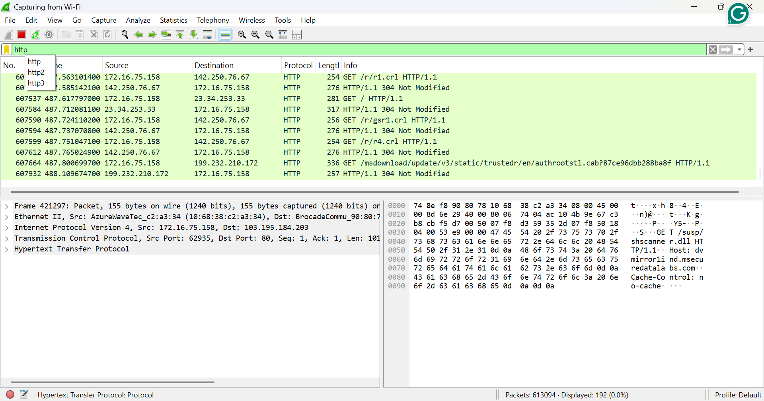
Observation:
From the captured packets:
- Protocol: HTTP
- Source IP Address: 172.16.75.158
- Destination IP Address: 103.195.184.203 (from selected packet)
- Source Port: 62935
- Destination Port: 80
- Request Method: GET
- HTTP Version: HTTP/1.1
- Response Code: 304 Not Modified
- Data Visibility: Plain text (readable request and headers)
Result:
HTTP packets were successfully analyzed.

Experiment 6: ARP Packet Analysis
Aim:
To analyze ARP request and reply packets.
Procedure:
- Open Wireshark and start packet capture on the active interface (Wi-Fi)
- Generate ARP traffic by:
  - Reconnecting to the network or
  - Running command: arp -d *
- Stop capture after a few seconds
- Apply the display filter: arp
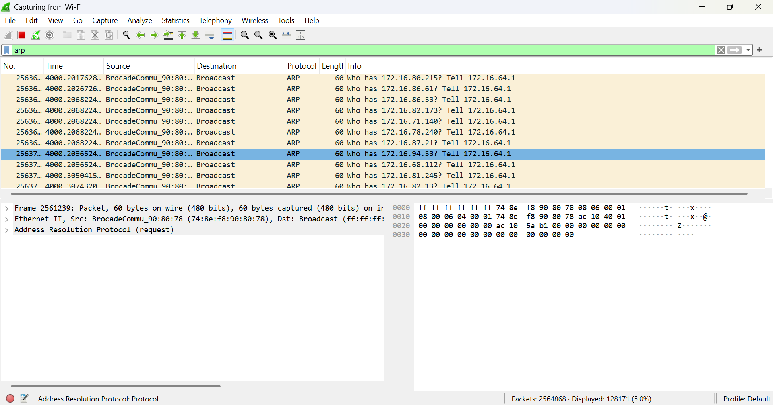
- Protocol: ARP
- Packet Type: ARP Request
- Source MAC Address: 74:8e:f8:90:80:78
- Destination MAC Address: ff:ff:ff:ff:ff:ff (Broadcast)
- Query:
  - “Who has 172.16.94.53? Tell 172.16.64.1”
- Packet Length: 60 bytes
Key observations:
- ARP request is sent as a broadcast to all devices
- The sender is trying to find the MAC address of the target IP
- Broadcast address confirms all devices receive the request

Experiment 7: MAC & IP Address Identification
Aim:
To identify source and destination MAC and IP addresses from captured packets.

Procedure:
- Open Wireshark and select any captured packet
- Expand the Ethernet II section to view MAC addresses
- Expand the Internet Protocol (IP) section to view IP addresses
- Note down the source and destination details
Observation:
- Source IP: 172.16.75.158
- Destination IP: 54.147.166.142
- Source MAC: (from Wireshark)
- Destination MAC: (from Wireshark)
Result:
MAC and IP addresses were successfully identified.

